

**Touchstones**

***Netcards***

**Harmony Netcards with Text**

All Creation HRJ

Barbershop Quartet HRJ

Bee HRJ

Being Right HRJ

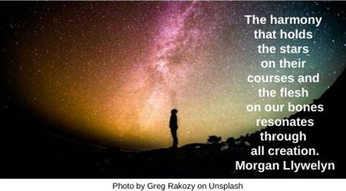

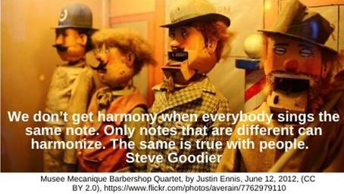

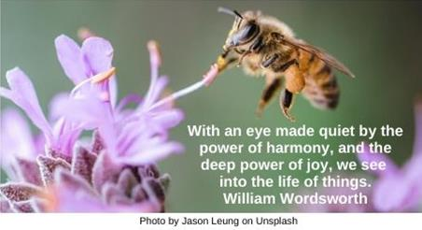

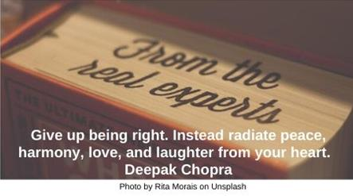

Buddha HRJ

Contradiction HRJ

Disturbance HRJ

Education HRJ

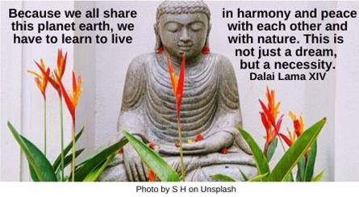

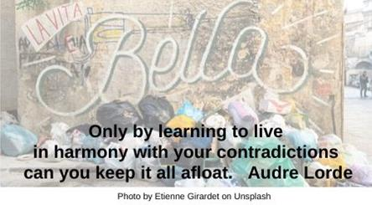

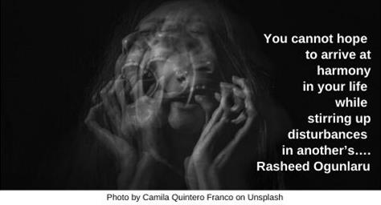



Fear HRJ

Flower HRJ

Harmony in Nature HRJ

Head and Heart HRJ

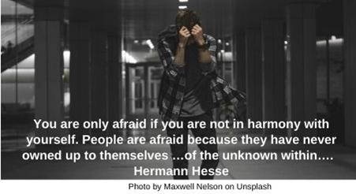

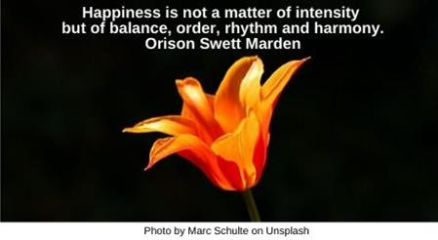

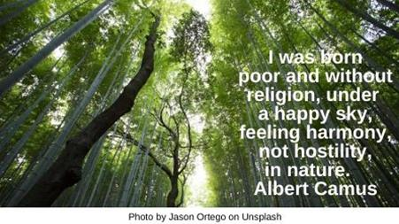

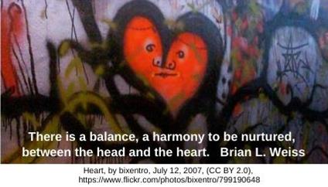

Human Ambition HRJ

Imperfection HRJ

Jazz HRJ

Mathematics HRJ

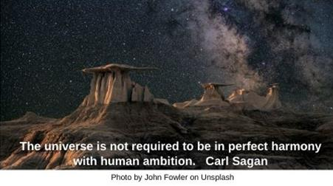

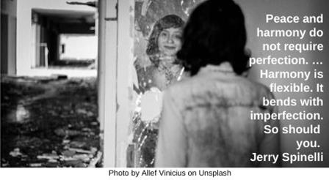

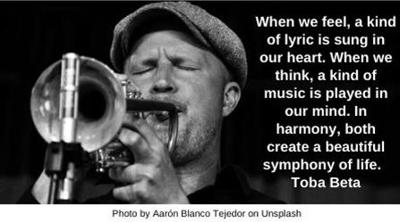

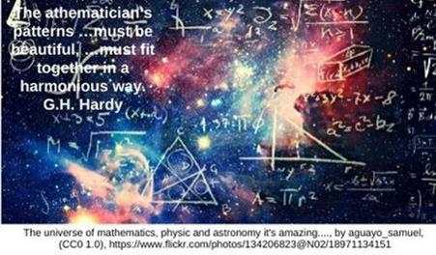

Nature HRJ

Obsolete HRJ

Paperwork HRJ

Peace HRJ

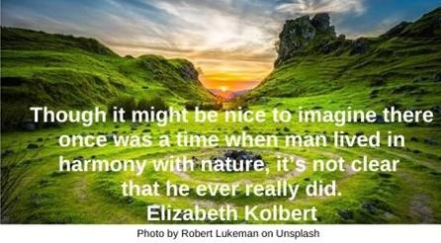

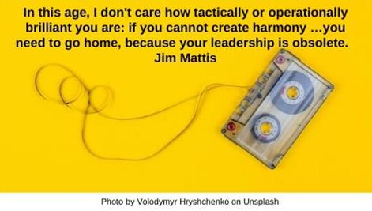

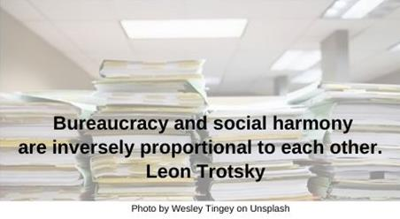

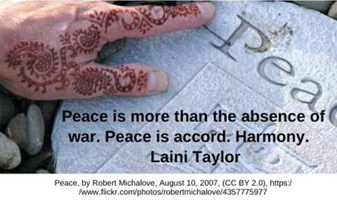

Plans HRJ

Rejoice HRJ

Reverence HRJ

Small Town HRJ





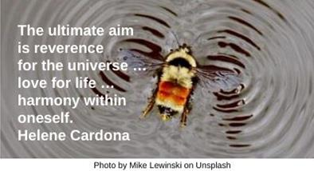

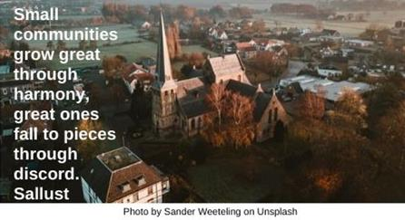

Stars HRJ

Tragedy HRJ

Trash HRJ

Van Gogh HRJ

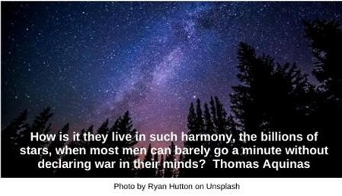



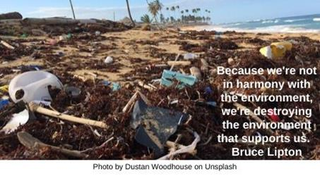

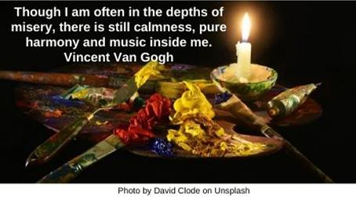

Wandering HRJ

Yin Yang HRJ

Yoga HRJ

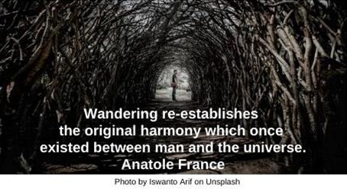

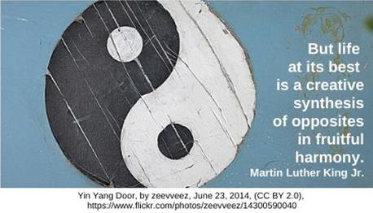

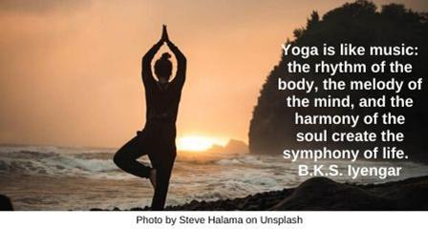

**Text of Quotes**

All Creation

The harmony that holds the stars on their courses and the flesh on our bones resonates through all creation. Morgan Llywelyn

Barbershop Quartet

We don’t get harmony when everybody sings the same note. Only notes that are different can harmonize. The same is true with people. Steve Goodier

Bee

With an eye made quiet by the power of harmony, and the deep power of joy, we see into the life of things. William Wordsworth

Being Right

Give up being right. Instead radiate peace, harmony, love, and laughter from your heart. Deepak Chopra

Buddha

Because we all share this planet earth, we have to learn to live in harmony and peace with each other and with nature. This is not just a dream, but a necessity. Dalai Lama XIV

Contradiction

Only by learning to live in harmony with your contradictions can you keep it all afloat. Audre Lorde

Disturbance

You cannot hope to arrive at harmony in your life while stirring up disturbances in another’s…. Rasheed Ogunlaru

Education

The highest education is that which does not merely give us information but makes our life in harmony with all existence. Rabindranath Tagore

Fear

You are only afraid if you are not in harmony with yourself. People are afraid because they have never owned up to themselves …of the unknown within…. Hermann Hesse

Flower

Happiness is not a matter of intensity but of balance, order, rhythm and harmony. Orison Swett Marden

Harmony in Nature

I was born poor and without religion, under a happy sky, feeling harmony, not hostility, in nature. Albert Camus

Head and Heart

There is a balance, a harmony to be nurtured, between the head and the heart. Brian L. Weiss

Human Ambition

The universe is not required to be in perfect harmony with human ambition. Carl Sagan

Imperfection

Peace and harmony do not require perfection. …Harmony is flexible. It bends with imperfection. So should you. Jerry Spinelli

Jazz

When we feel, a kind of lyric is sung in our heart. When we think, a kind of music is played in our mind. In harmony, both create a beautiful symphony of life. Toba Beta

Mathematics

The mathematician’s patterns …must be beautiful, …must fit together in a harmonious way. G.H. Hardy

Nature

Though it might be nice to imagine there once was a time when man lived in harmony with nature, it’s not clear that he ever really did. Elizabeth Kolbert

Obsolete

In this age, I don't care how tactically or operationally brilliant you are: if you cannot create harmony …you need to go home, because your leadership is obsolete. Jim Mattis

Paperwork

Bureaucracy and social harmony are inversely proportional to each other. Leon Trotsky

Peace

Peace is more than the absence of war. Peace is accord. Harmony. Laini Taylor

Plans

We planned for betrayal. They planned for deceit. No one ever thought to plan for harmony. Jonathan Hickman

Rejoice

If humans can live in harmony with other forms of life, the world rejoices. If not, the world suffers—and may not survive. T.A. Barron

Reverence

The ultimate aim is reverence for the universe …love for life …harmony within oneself. Helene Cardona

Small Town

Small communities grow great through harmony, great ones fall to pieces through discord. Sallust

Stars

How is it they live in such harmony, the billions of stars, when most men can barely go a minute without declaring war in their minds? Thomas Aquinas

Tragedy

All the tragedy in the world, in the individual and in the multitude, comes from lack of harmony. And harmony is the best given by producing harmony in one’s own life. Hazrat Inayat Khan

Trash

Because we're not in harmony with the environment, we're destroying the environment that supports us. Bruce Lipton

Van Gogh

Though I am often in the depths of misery, there is still calmness, pure harmony and music inside me. Vincent Van Gogh

Wandering

Wandering re-establishes the original harmony which once existed between man and the universe. Anatole France

Yin Yang

But life at its best is a creative synthesis of opposites in fruitful harmony. Martin Luther King Jr.

Yoga

Yoga is like music: the rhythm of the body, the melody of the mind, and the harmony of the soul create the symphony of life. B.K.S. Iyengar